**Assignment – 2 - Solution**

---------------------------------------------------------------------

eMasters in Communication Systems, IITK

EE901: Probability and Random Processes

Student Name : Venkateswar Reddy Melachervu

Roll No: 23156022

---------------------------------------------------------------------

**Q1. In an experiment, two dice are rolled. Consider the sigma-algebra containing all possible subsets of the sample space. Let X be the larger of the two numbers shown. Compute the list of intervals in $R$ the events in sigma algebra map to.**

**Solution:**

The total set of possible outcomes = $6^{2}=36$

X is the larger of the two numbers displayed on the dice.

Hence, the sample space/ $Ω$ =

|  |  |
| --- | --- |
| $σ$**-algebra** | **Value of X** |
| (1,1) | 1 |
| (1,2),(2,2),(2,1) | 2 |
| (1,3), (2,3),(3,3),(3,2),(3,1) | 3 |
| (1,4),(2,4),(3,4),(4,4),(4,3),(4,2),(4,1) | 4 |
| (1,5),(2,5),(3,5),(4,5),(5,5),(5,4),(5,3),(5,2),(5,1) | 5 |
| (1,6),(2,6),(3,6),(4,6),(5,6),(6,6),(6,5),(6,4),(6,3),(6,2),(6,1) | 6 |

**Q2:** **For the previous question, compute the corresponding events to the**

**X $∈$ [2; 4] and X $∈$ [1].**

**Solution:**

The events corresponding to X ∈ [2; 4] :

{(1,2),(2,2),(2,1),(1,3),(2,3),(3,3),(3,2),(3,1), (1,4),(2,4),(3,4),(4,4),(4,3),(4,2),(4,1)}

The events corresponding to X ∈ [1] :

{(1,1)}

**Q3:** Let $Ω$ be the sample space. Find and plot the CDF of X where:

(a) X($ω$) = c (c is a constant).

(b) X($ω$) = 1 for $ω∈$ A and X($ω$) = 2 otherwise, with P(A) = $\frac{1}{3}$

**Solution:**

(a)

|  |  |  |
| --- | --- | --- |
| **x** | $$E_{b}=\{ω:X\left(ω\right)∈B\}$$ | $$P_{X}(B)$$ |
| $$x<c$$ | $$ϕ$$ | 0 |
| $$x≥c$$ | $$Ω$$ | 1 |

The CDF of X is:

$$F_{X}\left(x\right)= \left\{\begin{aligned}0, if x<c \\ 1, if x≥c\end{aligned}\right.$$

**CDF Plot of X($ω$) = c**

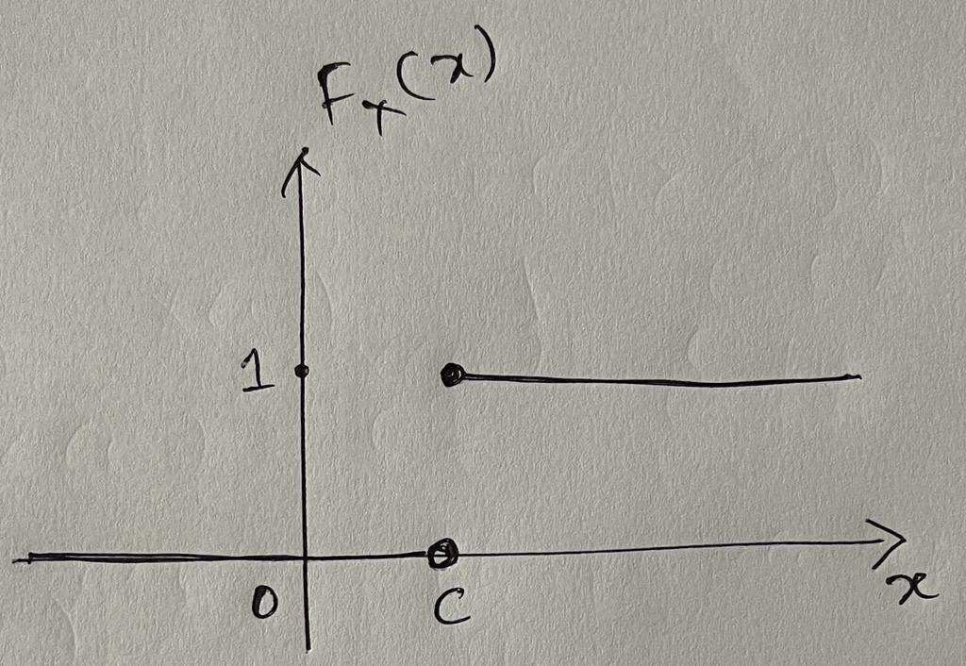

(b)

|  |  |  |
| --- | --- | --- |
| **x** | $$E_{b}=\{ω:X\left(ω\right)∈B\}$$ | $$P_{X}(B)$$ |
| $$x<1$$ | $$ϕ$$ | 0 |
| $$1≤x≤2$$ |  | $$\frac{1}{3}$$ |
| $$x≥2$$ |  | 1 |

The CDF of X is:

$$F_{X}\left(x\right)= \left\{\begin{aligned}0, if x<1 \\ \frac{1}{3}, if 1≤x<2 \\ 1, if x≥2\end{aligned}\right.$$

**CDF Plot of X($ω$) = 1 for $ω∈$ A and X($ω$) = 2 otherwise** 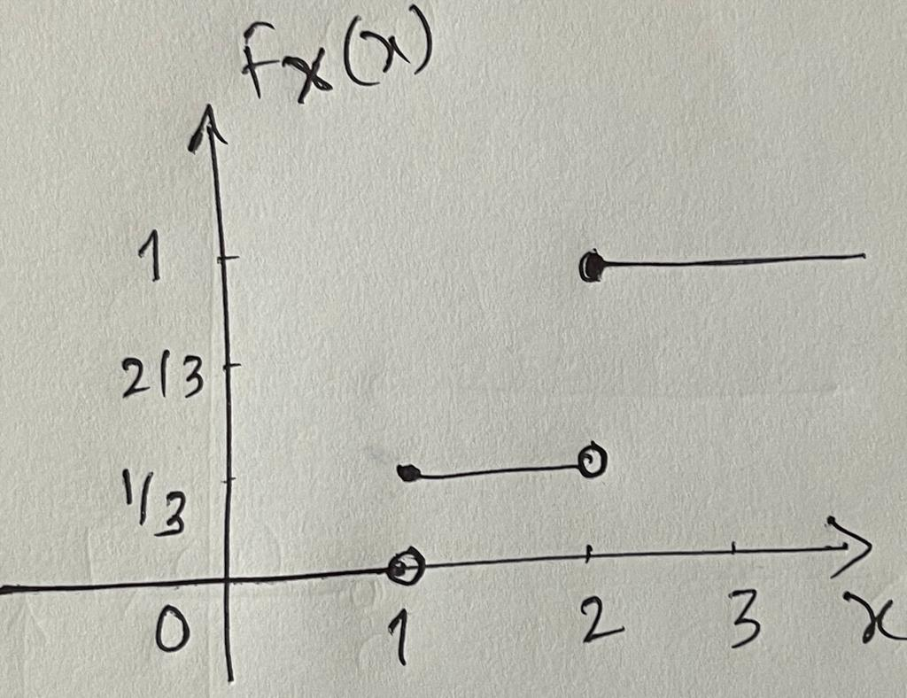

**Q4: Let $Ω$ = [0, 1] be the sample space and let P be a uniform probability measure on it such that P((a, b)) = b-a. Find and plot the CDF of X where X($Ω$) = 6 $ω^{2}$**

**Solution:**

CDF of X is:

$$F_{X}\left(x\right)=P\left[X\left(ω\right)≤x\right]=P\left[6ω^{2}≤x, ω∈\left[0,1\right]\right]=P\left[ω≤\sqrt{\frac{x}{6}}, w∈\left[0,1\right]\right]$$

Therefore, $F_{X}\left(x\right)=\left\{\begin{aligned}0, if x≤0 \\ \frac{\sqrt{x}}{6}, if 0<x<6 \\ 1, if x≥6\end{aligned}\right.$

**The CDF Plot of X($Ω$) = 6 $ω^{2}$**

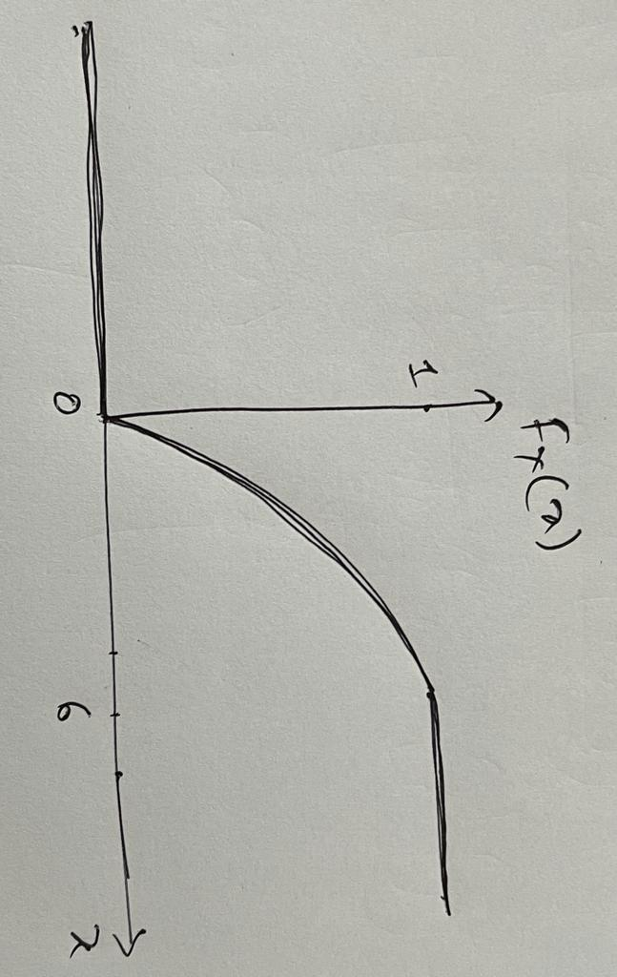

**Q5:** **Consider the experiment of tossing a coin three times. Let X be the random variable giving the number of heads obtained. We assume that the tosses are independent, and the probability of a head is $\frac{1}{3}.$**

1. What is the range of X?
2. Compute its PMF?
3. Compute the probability that X<2

**Solution:**

**(a) Range of X**

P(H) = 🡺 P(T) $=1-\frac{1}{3}=\frac{2}{3}$

|  |  |  |
| --- | --- | --- |
| Event | Value of X | Probability |
| {TTT} | X=0 | $$\frac{2}{3}*\frac{2}{3}*\frac{2}{3}=\frac{8}{27}$$ |
| {HTT,THT, TTH} | X=1 | $$3*\frac{1}{3}*\frac{2}{3}*\frac{2}{3}=\frac{4}{9}$$ |
| {HHT, HTH, THH} | X=2 | $$3*\frac{1}{3}*\frac{1}{3}*\frac{2}{3}=\frac{2}{3}$$ |
| {HHH} | X=3 | $$\frac{1}{3}*\frac{1}{3}*\frac{1}{3}=\frac{1}{27}$$ |

So, the outcomes of X are = {0,1,2,3} and hence the range of X is = [0,3]

**(b) PMF**

$$p_{X}\left(x\right)=\left\{\begin{aligned}\frac{8}{27}, if x=0 \\ \frac{4}{9}, if x=1 \\ \frac{2}{9}, if x=2 \\ \frac{1}{27}, if x=3\end{aligned}\right.$$

**(c) Probability of X<2**

$$P\left[X<2\right]=\frac{8}{27}+\frac{4}{9}=\frac{20}{27}$$

**Q6:** **The PDF of a continuous random variable X is given by**

$$f_{X}\left(x\right)=\left\{\begin{aligned}\frac{1}{4}, 0<x≤2 \\ \frac{3}{4}, 2<x≤4 \\ 0, otherwise\end{aligned}\right.$$

**Find the corresponding CDF $F_{x}\left(x\right).$ Sketch $f_{X}\left(x\right)$ and $F_{X}\left(x\right).$**

**Solution:**

Let’s look at the area covered by the PDF across the $Ω$/sample space that should be 1

$$\int_{-∞}^{∞}{f_{X}\left(x\right)dx= }\frac{1}{4}\left(2-0\right)+\frac{3}{4}\left(4-2\right)+0=\frac{4}{2}=2$$

Hence, the given function is not complaint to PDF principle.

However, if we divide each value of $f_{X}(x)$ by 2, the area can be complaint to 1.

Therefore,

$$f_{X}\left(x\right)=\left\{\begin{aligned}\frac{1}{8}, 0<x≤2 \\ \frac{3}{8}, 2<x≤4 \\ 0, otherwise\end{aligned}\right.$$

CDF, then is:

$$F_{X}\left(x\right)=\left\{\begin{aligned}\begin{aligned}0, if x<0 \\ \int_{0}^{x}{\frac{1}{8}dx=\frac{x}{8}, if 0<x≤2} \\ \int_{0}^{2}{\frac{1}{8}dx+ \int_{2}^{x}{\frac{3}{8}dx=\frac{1}{8}*\left[2-0\right]+\frac{3}{8}\left[x-2\right]=\frac{3x}{8}-\frac{1}{2}, if 2≤x<4}}\end{aligned} \\ 1, x≥4\end{aligned}\right.$$

**PDF - Plot**

**CDF - Plot**

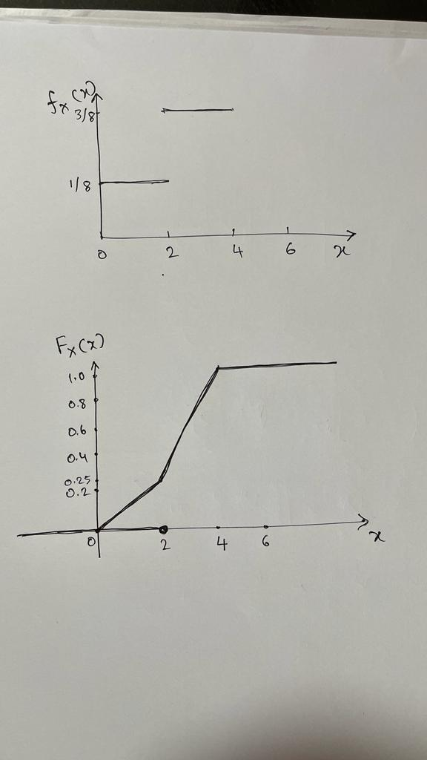

**Q7:** The PDF of a random variable X is given by:

$$f_{X}\left(x\right)= \left\{\begin{aligned}αx, 0<x<0.5 \\ 0, otherwise \end{aligned}\right.$$

Where $α$ is a constant. Find the value of $α$.

**Solution**

$$\int_{-∞}^{∞}{f_{X}\left(x\right)dx=1=>\int_{0}^{0.5}{αxdx=α{\left[\frac{x^{2}}{2}\right]}_{0}^{0.5}=α\left[\frac{{0.5}^{2}}{2}\right]=α\left[{\left(\frac{1}{2}\right)}^{2}*\frac{1}{2}\right]}}$$

$$∴α*\frac{1}{8}=1=>α=8$$

**Q8: In an exam, the question paper consists of four multiple-choice questions. A student who does not know any answer, randomly guesses the answers.**

1. What is the probability of getting exactly 3 questions correct?
2. What is the probability that you will write at least 2 questions correctly?

**Solution:**

**(a) Probability of Getting 3 Questions Correct**

If X is the student’s answer, it has two outcomes – correct and wrong for each of the question out of 3 questions. We can apply binomial RV here. Assuming 4 multiple choices for each question, the probability of “correct” outcome is ¼ and “wrong” outcome is ¾.

The binomial distribution $P\left(x\right)= {}_{x}^{n}Cp^{x}{(1-p)}^{n-x}$

Therefore, the probability of getting exactly 3 questions correct is :

P[X=3]= ${}_{3}^{4}C{(\frac{1}{4})}^{3}{(\frac{3}{4})}^{1}=\frac{3}{64}$

**(b) Probability of Getting at least 2 Questions Correct**

= Probability of getting 2, 3, and 4 questions correct

$P\left[X≥2\right]={{}_{2}^{4}{C\left(\frac{1}{4}\right)}}^{2}{(\frac{3}{4})}^{4-2}+{{}_{3}^{4}{C\left(\frac{1}{4}\right)}}^{3}{(\frac{3}{4})}^{4-3}+{{}_{4}^{4}{C\left(\frac{1}{4}\right)}}^{4}{(\frac{3}{4})}^{4-4}=\frac{67}{256}$

**Q9:** **The amount of time a person waits for a bus is uniformly distributed between zero and 15 minutes. What is the probability that a person waits less than 10 minutes?**

**Solution:**

Let X be the number of minutes a person waits for the bus. The PDF of X, then, is

$$f_{X}\left(x\right)=\frac{1}{(15-0)}=\frac{1}{15}$$

The probability that a person waits for less than 10 minutes is:

$$P\left[X≤10\right]=10*f_{X}\left(x\right)=10*\frac{1}{15}=\frac{2}{3}$$

**Q10:** **The time when a bulb of a specific company fails is an exponential random variable with mean .5 years. What is the probability that a bulb will fail in the third year.**

**Solution:**

To solve this problem, we need to use the cumulative distribution function (CDF) of the exponential distribution. The CDF gives us the probability that a random variable is less than or equal to a certain value.

The exponential distribution with mean (μ) has the probability density function (PDF):

f(x) = (1/μ) * exp(-x/μ) - where x is the time (in years) and exp denotes the exponential function.

The CDF (F(x)) is the integral of the PDF from 0 to x:

F(x) = $\int_{0}^{x}{f\left(t\right)dt}$ = $\int_{0}^{x}{\frac{1}{μ}*e^{-\frac{t}{μ}}dt}$

Given that the mean (μ) is 0.5 years, the parameter λ (rate parameter) of the exponential distribution can be calculated as λ = 1/μ = 1/0.5 = 2.

Now, we want to find the probability that a bulb will fail in the third year, which means x = 3. So, we need to evaluate the CDF at x = 3:

F(3) = $\int_{0}^{3}{\left(\frac{1}{2}\right)*e^{-\frac{t}{2}} }$

To find this integral, we can use integration by parts or look up the CDF of the exponential distribution.

The CDF of the exponential distribution with rate parameter λ is given by:

F(x) = 1 - $e^{-λx}$

Substituting our value of λ = 2, we get:

F(x) = 1 - $e^{-2x}$

Now, for x = 3:

F(3) = 1 - $e^{-\left(2*3\right)}$

F(3) = 1 - $e^{-6}$

Using a calculator, we find that F(3) ≈ 0.9975. So, the probability that a bulb will fail in the third year is approximately 0.9975, or 99.75%.